Temperature Sensors Test Report

# Test Components:

|  |  |  |
| --- | --- | --- |
| **Sensor Description** | **Part Number** | **Output Interface** |
| TI ±0.1°C Precision Analog Temperature Sensor | LMT70 | Analog (Voltage) |
| Microchip MCP9808 digital temperature sensor with ±0.5°C (max.) accuracy | MCP9808 | I2C upto 400KHz |
| TI digital humidity sensor with integrated temperature sensor  Relative Humidity Accuracy ±2% (typical)  Temperature Accuracy ±0.2°C (typical) | HDC1080 | I2C upto 400KHz |
| Silicon Labs digital humidity sensor with integrated temperature sensor  Relative Humidity Accuracy ±3% (typical)  Temperature Accuracy ±0.4°C (typical) | Si7021 | I2C upto 400KHz |

# Test on 5/11

## Task1:

Measure room temperature, which is set to 78**°**F (25.5**°**C). The LMT70 evaluation board and HDC1080 evaluation board are placed side by side on a desk facing up. The measurement screenshots are taken 15 min after the first measurement started.

Conclusion: The result from LMT70 is very close to the room temperature the set by the thermostat while the result from HDC1080 is about 1**°**C higher than expected room temperature.

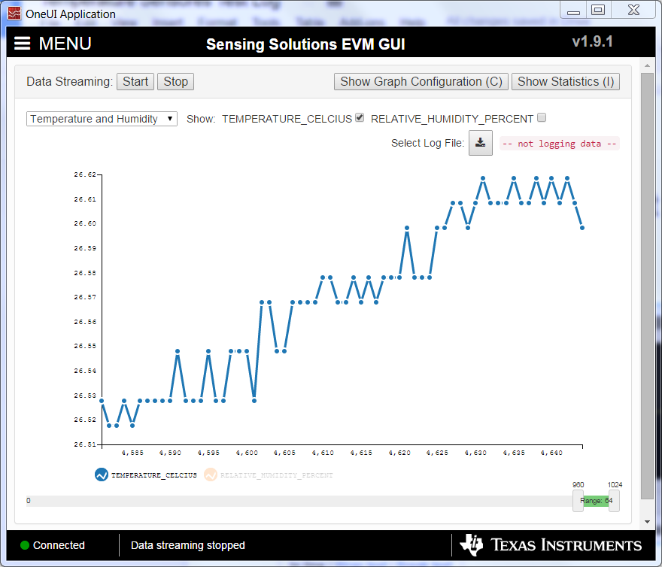

Figure : Test results of HDC1080

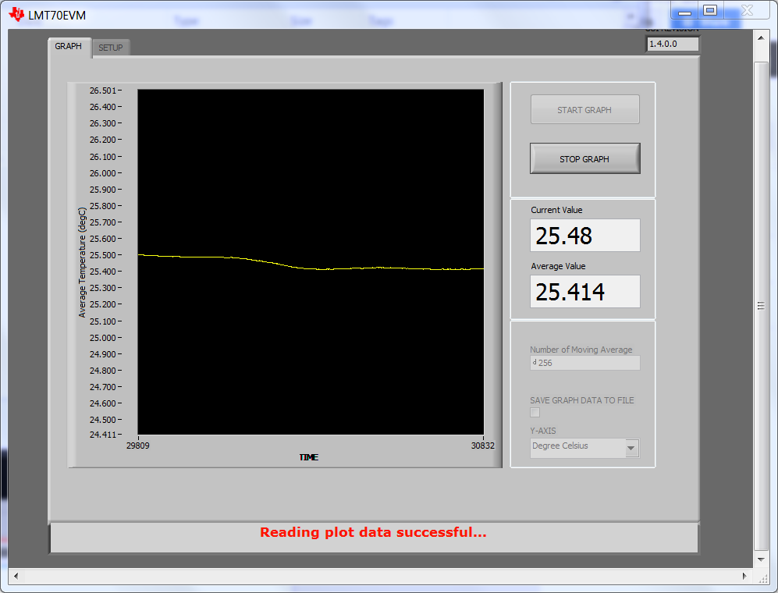

Figure : Test results of LMT70

# Test on 5/30

Measure room temperature, which is set to 78**°**F (25.5**°**C). The LMT70 evaluation board and HDC1080 evaluation board are placed side by side on a desk facing up. The MCP9808 sensor board and the Si7201 sensor board is each connected to a MSP430F5529 launch board, which is communicated to them via I2S and the results are displayed on a terminal window via USB using virtual Comm connection. The measurement screenshots are taken 15 min after the first measurement started.

The following are a snapshot of the measurement results

|  |  |  |  |  |  |
| --- | --- | --- | --- | --- | --- |
|  | Thermostat | LMT70 | HDC1080 | MCP9808 | Si7201 |
| Temperature (**°**C) | 25.5 | 25.90 | 27.17 | 25.7696 | 25.625 |
| Humidity (RH %) |  | N/A | 51.05 | N/A | 51.3845 |

Conclusion: once again, reading from HDC1080 is more than 1**°**C higher than the reading from other 3 sensors. I will use another HDC1080 board to do the measurement again to rule out any hardware failure.

# Test on 6/1

Measure room temperature, which is set to 78**°**F (25.5**°**C). The LMT70 evaluation board and HDC1080 evaluation board are placed side by side on a desk facing up. The MCP9808 sensor board and the Si7201 sensor board is each connected to a MSP430F5529 launch board, which is communicated to them via I2S and the results are displayed on a terminal window via USB using virtual Comm connection. The measurement screenshots are taken 15 min after the first measurement started. I also used a precision thermometer to measure the room temperature and use its reading as a reference

The following are a snapshot of the measurement results

|  |  |  |  |  |  |
| --- | --- | --- | --- | --- | --- |
|  | Thermometer | LMT70 | HDC1080 | MCP9808 | Si7201 |
| Temperature (**°**C) | 25.44 | 26.18 | 27.86 | 26.00 | 25.97 |

Conclusion: All 4 sensors readings are at least 0.5**°**C higher than the reading from a precision thermometer, which is used as a referencing point. At the same time, the reading from the HDC1080 continues to demonstrate it is way off compares to the other 3 sensors. I think we should remove it from our candidate list.